**Ideation Phase**

**Empathize & Discover**

| Date | 13 October 2022 |
| --- | --- |
| Team ID | PNT2022TMID52175 |
| Project Name | Personal Assistance for Seniors Who Are Self-Reliant |
| Maximum Marks | 4 Marks |

**Empathy Map Canvas:**

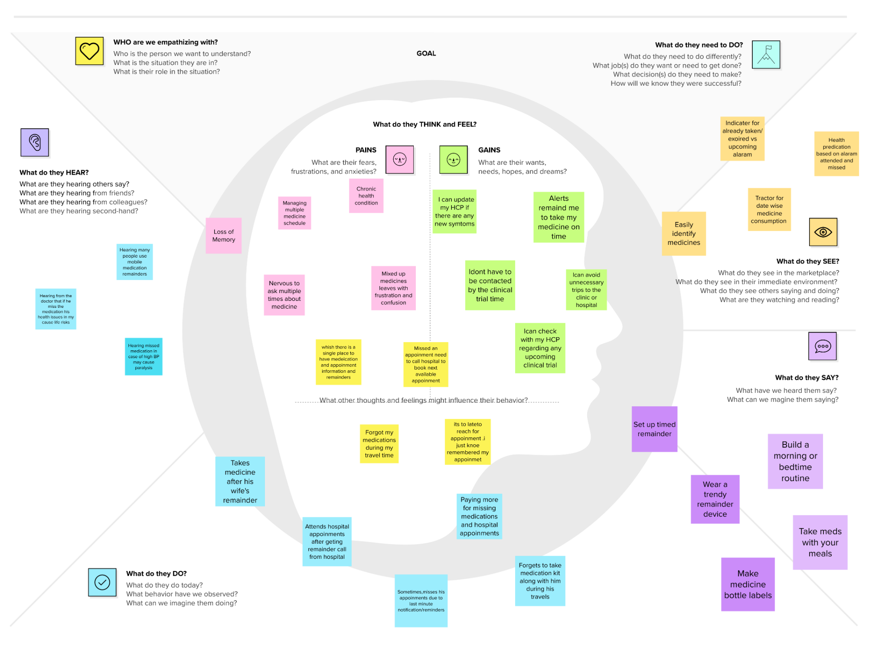

Reference:https://app.mural.co/t/bebishatherese9110/m/bebishatherese9110/1665564603707/d071db1bd0512a4cbf4abb1d2096498b277fa976?sender=u8faea63cd92c8fd5702c6889